Feature:
----------
1. Server is IP Protocol independent, it can handle both IPv4 and IPv6 addresses.
2. Client may open a socket with 'ai_family' = AF_INET or AF_INET6.

Technical:
--------------
1. Client may open a socket with 'ai_family' = AF_INET/AF_INET6.
2. Client uses getaddrinfo to get the address family information depending on the ipv4 or ipv6 address given as input.
3. Server opens a IPv6 socket with address family 'in6addr_any'.
4. Server will listen to any IP address and stores the client information in 'sockaddr_storage'.

Reference:
----------------
http://man7.org/linux/man-pages/man2/socket.2.html
http://man7.org/linux/man-pages/man3/getaddrinfo.3.html
http://man7.org/linux/man-pages/man3/getnameinfo.3.html
http://pubs.opengroup.org/onlinepubs/009696699/basedefs/sys/socket.h.html
http://www.ibm.com/support/knowledgecenter/ssw_i5_54/rzab6/xacceptboth.htm

Screenshots:
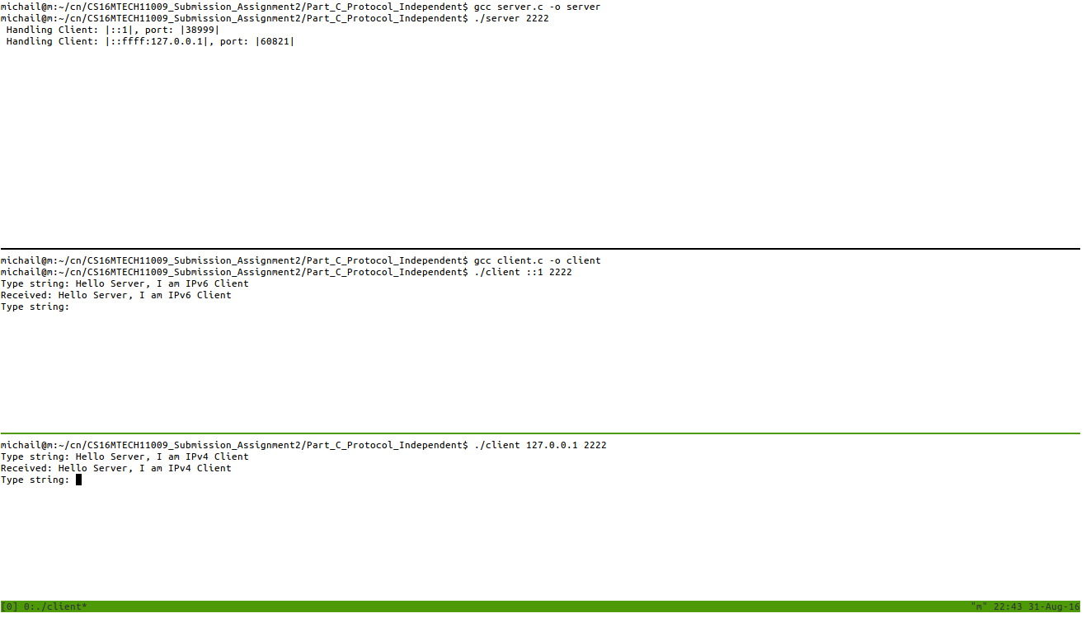
------------------
Server accepts both Ipv4 and Ipv6 clients.

